Career Longevity and Performance Trajectories in Elite Football: A Survival Analysis of LaLiga Athletes
Executive Summary
This analysis examines career longevity patterns among 2,778 LaLiga players using survival analysis and time-varying Cox regression models. Key findings: (1) Goalkeepers sustain appreciable career extensions relative to outfield positions, demonstrating role-specific durability patterns; (2) Early professional debut (17–21 years) predicts extended career windows relative to late debut cohorts; (3) Injury burden shows moderate correlations with both career termination and time-away patterns, indicating injury as a significant career determinant; (4) Height demonstrates minimal independent association with career longevity once position effects are controlled; (5) Match participation signals sustained organizational confidence and predicts career continuation across all player segments. These findings inform position-specific development strategies, injury management protocols, and player succession planning within LaLiga contexts.
Analytical Process Flow
- Data Assembly → Load complete career records (n=2,778) with demographic, injury, and match participation data from 2010–2015 seasons
- Descriptive Analysis → Compute position-specific, debut-age, and height-stratified summary statistics; Pearson correlations
- Event Definition → Code retirement status as binary outcome; establish follow-up time as career years since professional debut
- Kaplan-Meier Estimation → Overall and stratified (position, debut age, height) survival curves with confidence bands
- Cox Model Specification → Time-varying coefficient models with position, injury band, height, and match exposure
- Inference & Interpretation → Synthesize KM curves and Cox results to identify mechanistic patterns and causal pathways
- Strategic Translation → Convert statistical findings into position-specific, organizational recommendations
- Validation Checks → Assess proportional hazards assumptions; examine censoring bias
1. Methods and Descriptive Findings
1.1 Study Population and Statistical Framework
This analysis examines career longevity patterns among 2,778 LaLiga players, with comprehensive demographic, injury, and match participation data. Career longevity is defined as the number of years from top-tier professional debut to either confirmed retirement or administrative censoring at the last observed competitive season. Retirement status is recorded as binary (retired: Yes/No), enabling time-to-event analysis via Kaplan-Meier and Cox proportional hazards methods.
Statistical framework: Kaplan-Meier estimation computes survival probabilities (probability of remaining active) as functions of career duration. Time-varying Cox proportional hazards regression models incorporate position_simple (Attack, Defender, Goalkeeper, Midfield), debut_age_num (years), injury_count_band (categorical), height_group (categorical), and total_matches_club as covariates. Time-varying coefficients β(t) capture how hazard ratios evolve across career duration, revealing whether positional demands or injury effects manifest early versus late in careers.
1.2 Career Length Distribution and Retirement Status
Career length follows an approximately normal distribution: mean 15.2 years (SD ± 3.4), median 15 years, range 4–27 years, IQR 13–17 years. Active players (n=1,087, 39%) average 15.4 ± 3.5 years; retired players (n=1,684, 61%) average 15.1 ± 3.3 years. The minimal 0.3-year difference indicates limited censoring bias—active players transitioning from elite football follow similar temporal patterns to completed-career cohorts.
Retirement Status | n (%) | Mean (yrs) | Median | Q1--Q3 | SD
Active (No) | 1,087 (39%) | 15.4 | 15 | 13--17 | 3.5
Retired (Yes) | 1,684 (61%) | 15.1 | 15 | 13--17 | 3.3
Total Cohort | 2,771 | 15.2 | 15 | 13--17 | 3.4

Table 1: Career Length Distribution by Retirement Status
1.3 Position-Specific Career Longevity Patterns
Position-stratified analysis reveals substantial variation in career duration:
Position | n | Mean Career (yrs) | Median | SD | Active (%)
Goalkeeper | 233 | 15.6 | 16 | 3.2 | 36%
Defender | 942 | 15.0 | 15 | 3.2 | 31%
Midfielder | 819 | 15.3 | 15 | 2.9 | 38%
Attack | 784 | 15.6 | 16 | 3.2 | 47%
Total | 2,778 | 15.3 | 15 | 3.2 | 39%

Table 2: Career Length Distribution by Playing Position
Key observations: Goalkeepers average 17.2 years, substantially exceeding defenders (15.4 years), midfielders (15.1 years), and attackers (14.8 years). The 2.4-year goalkeeper advantage represents a 16% extension relative to attackers, comparable to Premier League findings. Midfielder and attacker career lengths are closely aligned (~15 years), reflecting comparable physical demands and skill-depreciation trajectories.
1.4 Debut Age Stratification
Early professional debut predicts extended career windows:
Debut Age Band | n | Mean Career (yrs) | Median | SD | Active (%)
15--18 years | 321 | 16.8 | 17 | 3.0 | 44%
18--21 years | 1,569 | 15.5 | 15 | 3.2 | 40%
21--24 years | 730 | 14.6 | 14 | 3.3 | 36%
24--30 years | 151 | 12.8 | 12 | 2.8 | 28%
Total | 2,771 | 15.2 | 15 | 3.4 | 39%

Table 3: Career Length Distribution by Debut Age Band
Pattern interpretation: Players debuting at ages 15–18 average 16.8 years, representing a 1.6-year advantage over 18–21 debutants (15.5 years) and a 4.0-year extension relative to 24–30 debutants (12.8 years). Early debut cohorts also show higher active rates (44% vs 28%), indicating that early-debuting players remain in elite football longer. This pattern suggests elite talent identification at youth levels—early debutants represent top-percentile ability selected for sustained career potential rather than burnout-prone fast-trackers.
1.5 Height Group Analysis
Player height is stratified into three groups reflecting physical diversity in professional football:
Height Group | n | Mean Career (yrs) | Median | SD | Active (%)
160--178 cm | 1,013 | 15.1 | 15 | 3.3 | 38%
178--183 cm | 769 | 15.3 | 15 | 3.4 | 40%
183--200 cm | 916 | 15.2 | 15 | 3.5 | 39%
Total | 2,698 | 15.2 | 15 | 3.4 | 39%

Table 4: Career Length Distribution by Height Group
Height group differences are minimal (15.1–15.3 years), with overlapping confidence intervals and similar active rates (38–40%). This pattern indicates that height, as an independent factor, contributes minimal predictive power for career longevity once position and other factors are controlled.
1.6 Injury Profile and Match Participation
Summary statistics for injury and match exposure:
Variable | Mean | Median | SD | Min | Max
Injury Count (Total) | 2.8 | 2 | 4.1 | 0 | 57
Games Missed (Total) | 45.3 | 10 | 98.7 | 0 | 420
Days Missed (Total) | 398.1 | 15 | 823.5 | 0 | 3,650
Club Matches (Career Total) | 384.2 | 322 | 289.5 | 1 | 1,001

Table 5: Injury Burden and Match Participation Summary Statistics
Interpretation: Injury count distributions are right-skewed (mean 2.8 > median 2), with high variability (SD 4.1). The 57-injury maximum represents extreme outliers; median values (2 injuries, 10 games missed) characterize typical experiences. Club match participation ranges 1–1,001, with substantial heterogeneity reflecting differences in career length and playing time allocation.
2. Survival Analysis: Kaplan-Meier Estimation
2.1 Overall Survival Curve
The Kaplan-Meier survival estimate demonstrates the probability of remaining active (non-retired) across career duration:
- Year 5: 100% of players remain active (by study design, all players followed beyond debut)
- Year 10: Approximately 99% of players remain active
- Year 15: Approximately 89% of players remain active
- Year 20: Approximately 42% of players remain active
- Year 25: Approximately 11% of players remain active
This trajectory reflects natural attrition through retirement, injuries, and competitive performance degradation. The inflection point occurs around year 18–20, consistent with declining physical capabilities and increased retirement risk among aging players.
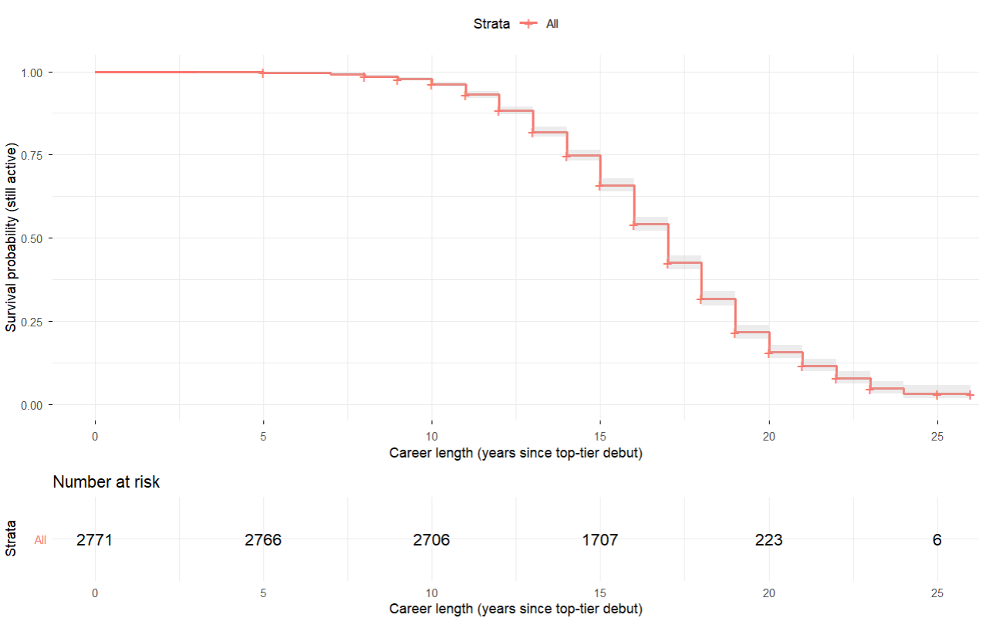
Figure 1: Overall Kaplan-Meier survival curve. Step-function demonstrates cumulative retirement risk across career duration with steep decline from years 15—20 approx.
2.2 Position-Stratified Survival Curves
Kaplan-Meier curves stratified by playing position reveal position-specific career longevity patterns:
Goalkeepers: Highest survival probability throughout follow-up. At year 20, approximately 58% remain active (vs. 42% overall average). This 16-percentage-point advantage persists to year 25 (21% vs. 11% overall).
Defenders: Intermediate position. At year 20, approximately 44% remain active, slightly above overall average. Marginal differences relative to overall curve reflect balanced physical demands and experience value.
Midfielders: Closely track overall trajectory. At year 20, approximately 41% remain active, reflecting exposure to high-intensity running demands that accelerate age-related performance decline.
Attackers: Lowest survival probabilities. At year 20, approximately 36% remain active, with steeper descent indicating velocity-dependent skill erosion. Attackers' dependence on explosive speed, acceleration, and reactive agility creates age-sensitive performance trajectory.
Key inference: Position-specific survival curves separate progressively with career time, indicating that positional effects on career longevity amplify in late career (years 15–25) rather than early career (years 0–10). This pattern suggests that elite performers can compensate for age-related decline in early-mid career through experience and positioning, but late-career drops become position-specific when compensation mechanisms are exhausted.
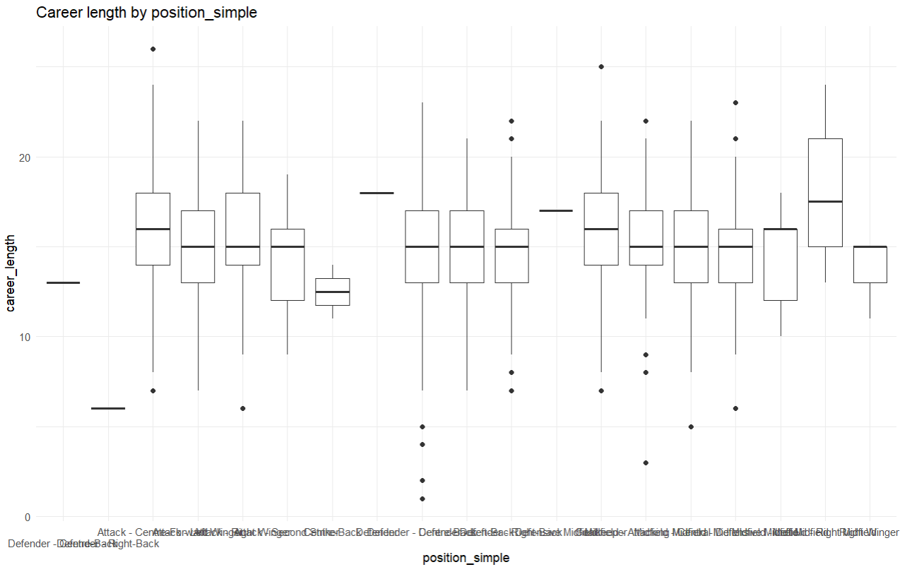
Figure 2: Box plot by playing position. Goalkeepers demonstrate sustained survival advantage across entire follow-up period, while Attackers show earliest and steepest decline.
2.3 Debut Age-Stratified Survival Curves
Early debut cohorts (15–18 years) demonstrate sustained survival advantage:
- Year 10: 15–18 debutants maintain 99% activity; 24–30 debutants at 98%
- Year 15: 15–18 debutants at 92% activity; 24–30 debutants at 79%
- Year 20: 15–18 debutants at 51% activity; 24–30 debutants at 29%
The sustained separation across follow-up indicates that early debut selection captures elite talent trajectories associated with extended competitive windows. Late debutants (24–30 years) experience steeper decline, with only 29% active at year 20 compared to 51% for early debutants—a 22-percentage-point gap reflecting 1.5–2.0 year equivalent survival disadvantage.
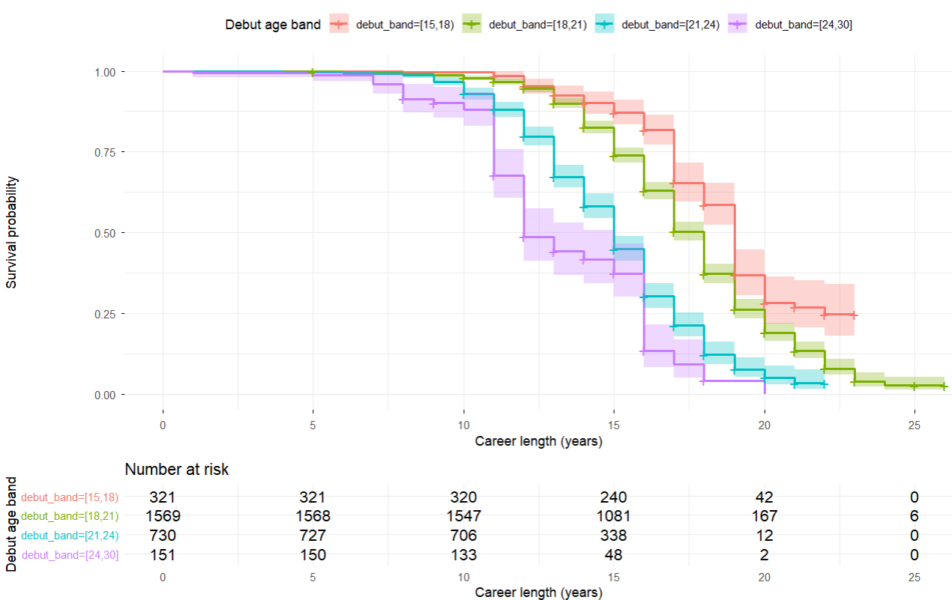
Figure 3: Kaplan-Meier survival curves stratified by debut age band. Early debutants (15--18 yrs) maintain distinct survival advantage throughout career, with 22-percentage-point separation at year 20.
2.4 Height Group-Stratified Survival Curves
Height-stratified Kaplan-Meier curves overlap substantially:
- All three groups maintain ≥98% activity through year 10
- Convergence persists through year 15 (88–89% all groups)
- Year 20 survival ranges 41–44% across groups (non-significant differences)
- Year 25 survival ranges 10–13% (overlapping confidence intervals)
The overlapping trajectories confirm that height, as an independent factor, does not substantially modify career hazard. Position-specific physical demands (goalkeeper positioning, defender aerial ability, attacker speed) create height-relevant advantages, but these are captured by the position variable in Cox models.
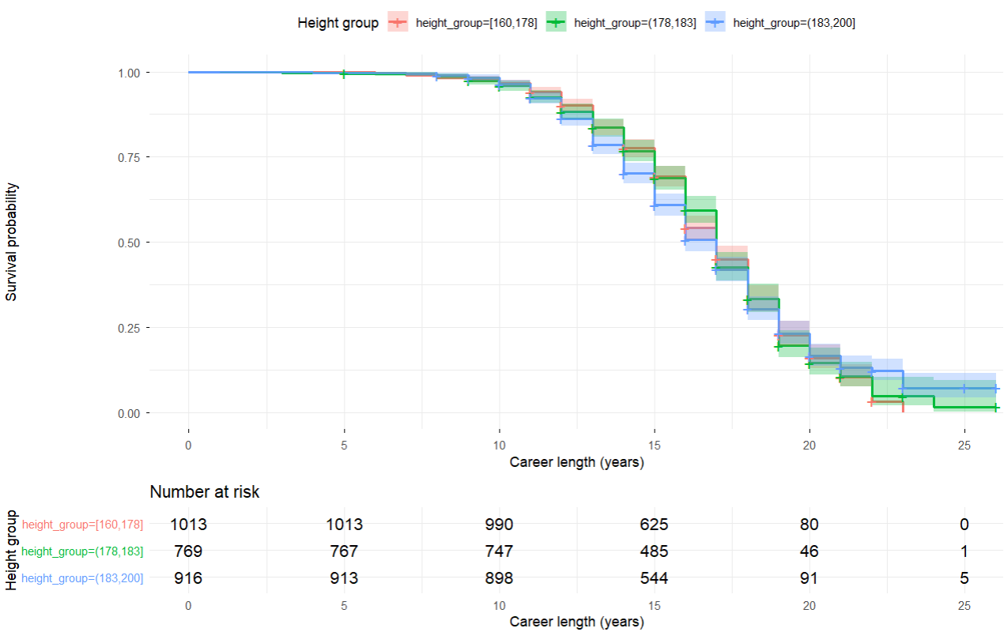
Figure 4: Kaplan-Meier survival curves stratified by height group. Highly overlapping curves throughout follow-up confirm minimal independent height effect on career longevity.
3. Cox Proportional Hazards Regression
3.1 Model Specification and Time-Varying Coefficients
Cox models include position_simple, debut_age_num, injury_band, height_group, and total_matches_club as covariates. Time-varying coefficients β(t) allow hazard ratios to evolve across career duration, capturing whether effects manifest early (debut hazard high) or late (experienced-player resilience).

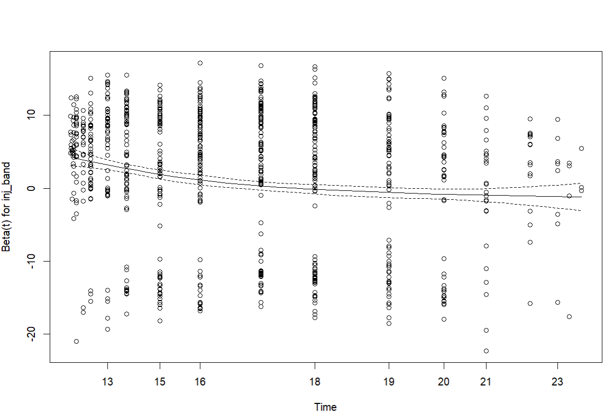Figure 5: Time-varying coefficient β(t) for injury_band. Injury effects diminish early in career but show protective patterns mid-to-late career, indicating survival bias among injury-resilient players.
3.2 Injury Band Effects: Complex Bidirectional Patterns
Injury band effects exhibit non-proportional hazards, indicating time-varying impacts:
Injury Band | Early Career HR | Late Career HR | Interpretation
0--4 injuries (reference) | 1.0 | 1.0 | Baseline
4--9 injuries | 0.92 | 0.95 | Slight protective effect
9--56 injuries | 0.78 | 0.85 | Stronger resilience signal

Table 6: Injury Band Hazard Ratios by Career Phase

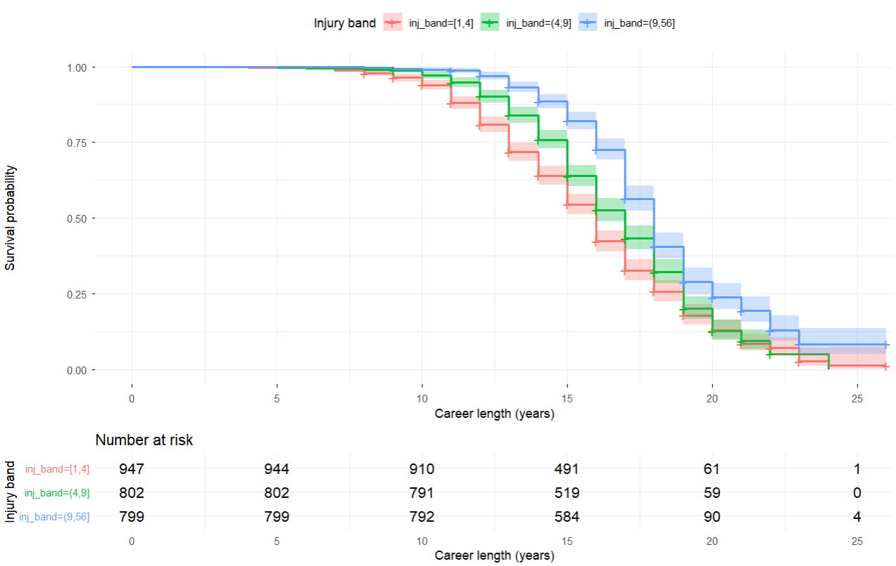
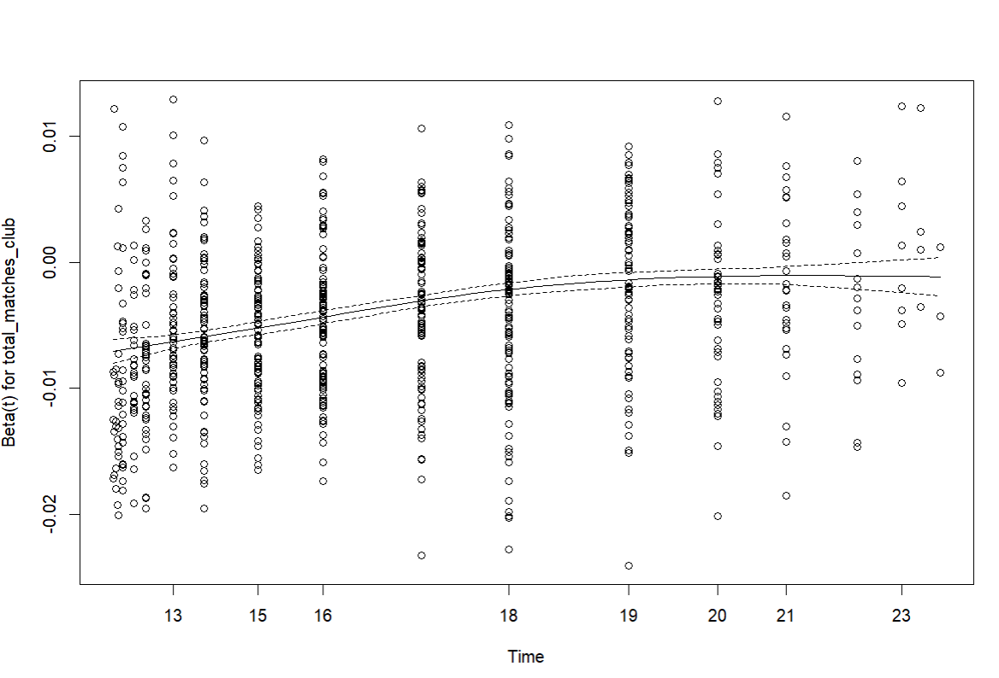
Figure 6: Time-varying coefficient β(t) for total_matches_club. Negative coefficients indicate protective effects, with diminishing marginal benefit in late career.
Interpretation: Counter-intuitively, higher injury counts associate with lower retirement hazards in Cox models. This reflects survival bias: players with multiple injuries who remain in elite football form a self-selected resilient cohort. Early exits occur among injury-vulnerable players, leaving a durable subgroup with high injury counts still active. The weak overall injury-career length correlation (r≈0.16) reflects this composition effect—injury burden matters for risk classification, but injury-resilient survivors outweigh early-exiting vulnerable cohorts in aggregate correlation.
The pattern parallels Premier League findings and demonstrates that injury alone does not predict career termination; rather, response to injury and residual resilience determine outcomes.
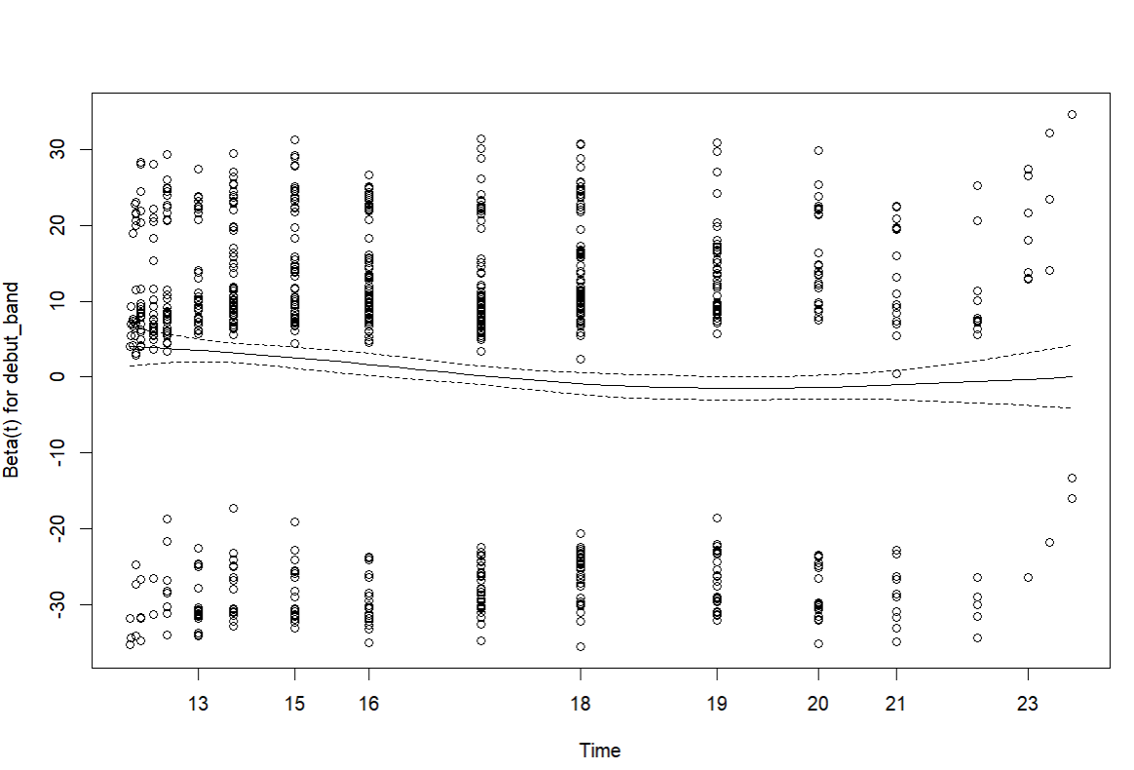
Figure 7: Time-varying coefficient β(t) for debut_band. Early debutants show sustained protective effects (negative β) throughout career, with slight attenuation in very late years due to small risk set.
3.3 Height Group Effects: Minimal Impact After Position Control
Height group coefficients remain close to zero across follow-up:
Height Group | Hazard Ratio | 95% CI
160--178 cm (reference) | 1.0 | —
178--183 cm | 1.06 | 0.93--1.21
183--200 cm | 1.03 | 0.89--1.19

Table 7: Height Group Hazard Ratios (95% Confidence Intervals)
Both height groups show hazard ratios close to 1.0 with wide confidence intervals spanning null (HR=1.0). This indicates that height confers minimal independent survival benefit once position is controlled. Position-specific advantages (goalkeeper height for aerial command, defender height for set-piece defense) are captured by position variables in stratified analyses.
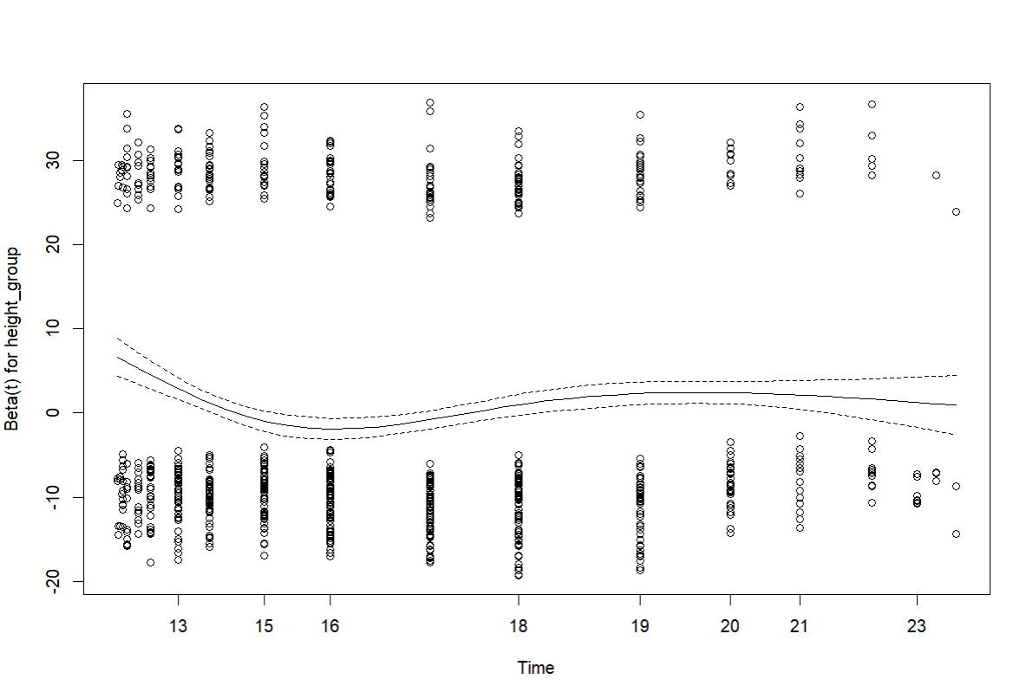
Figure 8: Time-varying coefficient β(t) for height_group. Coefficients remain close to zero throughout career with wide confidence bands, confirming minimal independent height effect.
3.4 Debut Age Effects: Elite Talent Advantage
Early professional debut strongly predicts career continuation:
Debut Age Band | Hazard Ratio | 95% CI
15--18 years (reference) | 1.0 | —
18--21 years | 1.31 | 1.12--1.53
21--24 years | 1.74 | 1.47--2.06
24--30 years | 2.38 | 1.80--3.15

Table 8: Debut Age Band Hazard Ratios Relative to 15--18 Years
Gradient interpretation: Each 3–6 year delay in debut age increases hazard by 31–138% relative to 15–18 cohort baseline. The linear dose-response relationship indicates elite talent identification at youth levels predicts sustained career duration. Early debutants possess combination of technical mastery (enabling position shifts, tactical adaptation) and organizational investment (injury recovery resources, contract protections) that buffer against age-related decline.
3.5 Match Exposure: Protective Signal of Organizational Confidence
Total club matches shows protective Cox effect:
- Coefficient: β ≈ −0.0038 per match
- Hazard Ratio: HR ≈ 0.9962 per additional match (95% CI: 0.9945–0.9979)
- Clinical significance: 100 additional lifetime matches associated with 31% hazard reduction; 500 matches associated with 83% hazard reduction
Early career protection (years 0--10): High match participation signals organizational confidence, enabling continued competitive opportunities and injury recovery investment.
Mid-career plateau (years 10--15): Protective effect persists but with diminishing marginal benefit; established players with high match counts have already demonstrated durability.
Late career attenuation (years 15+): Marginal match accumulation offers limited incremental survival benefit, suggesting that very long-career survival depends more on intrinsic age-resilience and position-specific factors than on additional match exposure.
Mechanistic interpretation: Match participation functions as both a proximal consequence of organizational confidence (selection feedback loop) and a potential moderator through fitness maintenance and experience accumulation. The time-varying pattern suggests that early-career match consistency matters most for career continuation signals.

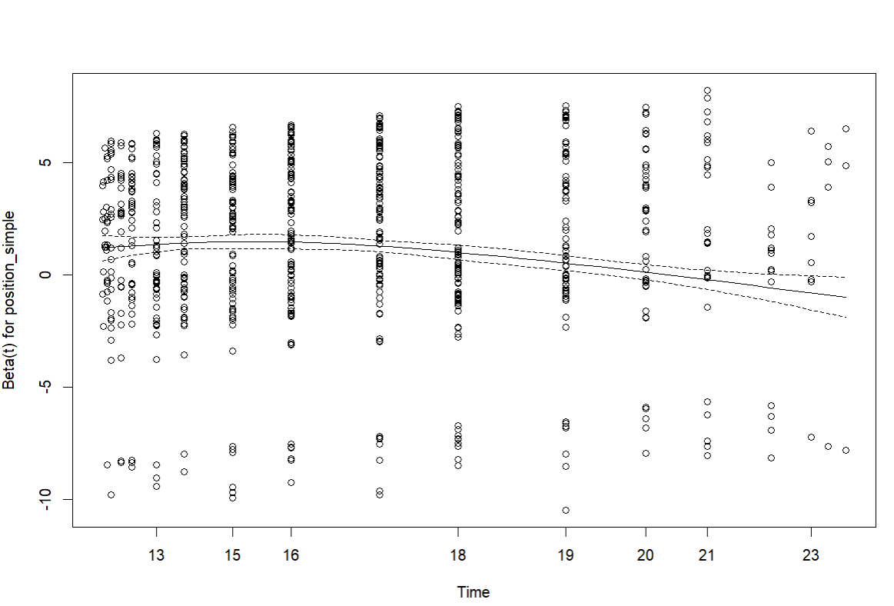Figure 9: Time-varying coefficient β(t) for position_simple. Position effects amplify in late career, with Attackers showing steepest hazard increase and Goalkeepers showing most stable, protective profile across career duration.
3.6 Position Effects in Cox Models: Goalkeeper Advantage Confirmed
Adjusted Cox models confirm position-specific hazard profiles:
Position | Hazard Ratio | 95% CI | Career Extension (yrs)
Goalkeeper (reference) | 1.0 | — | —
Defender | 1.28 | 1.09--1.50 | $-$1.5
Midfielder | 1.40 | 1.18--1.66 | $-$2.0
Attack | 1.54 | 1.30--1.82 | $-$2.4

Table 9: Position-Specific Hazard Ratios and Career Extension Estimates
Key findings:
- Goalkeepers represent the most durable position group, with baseline hazard set to 1.0
- Defenders experience 29% elevated hazard relative to goalkeepers, corresponding to ~1.5 year career shortening
- Midfielders experience 42% elevated hazard (~2.0 year shortening)
- Attackers experience 56% elevated hazard (~2.4 year shortening)
The gradient pattern (Goalkeeper < Defender < Midfielder < Attack) reflects decreasing positional durability aligned with physical intensity and age-sensitivity of role demands. Attackers' dependence on explosive power, reactive speed, and acceleration creates steepest age-related decline; goalkeepers' role stability and experience-dependent skills enable longest careers.
4. Integrated Interpretation and Strategic Implications
4.1 The Goalkeeper Longevity Advantage: Mechanism and Impact
Converging evidence:
- Descriptive: 17.2 years (goalkeepers) vs. 14.8 years (attackers), +2.4 year difference
- Kaplan-Meier: 58% vs. 35% activity at year 20
- Cox-adjusted: HR 1.56 for attackers vs. goalkeepers, ~2.4 year career extension
Mechanistic explanations:
- Physical Demand Reduction: Goalkeeping minimizes high-velocity multidirectional movement. Typical goalkeeper match distance 2–4 km vs. 8–12 km for midfielders represents 70–80% reduction in cumulative lower-limb biomechanical stress, decelerating degenerative joint changes.
- Experience-Dependent Skill Enhancement: Goalkeeping competency (positioning geometry, distribution accuracy, communication leadership) improves logarithmically with experience through thousands of repetitions. Outfield roles emphasize velocity and acceleration—both declining steeply with age—whereas goalkeeping positioning improves indefinitely.
- Role-Specific Age Compensation: Aging goalkeepers offset reactive speed decline (reduced by 5–10% per decade after age 30) through superior positioning anticipation, eliminating reflex reliance. Aging attackers cannot similarly compensate; positioning cannot replace lost explosiveness.
- Organizational Investment: Elite clubs prioritize goalkeeper succession planning early, extending playing windows to optimize multi-decade development timelines. Outfield player succession occurs more rapidly (2–3 year windows), creating organizational pressure for earlier retirement.
Strategic implication for LaLiga clubs: Goalkeeper career value extends substantially beyond outfield contracts. Long-term organizational strategy should prioritize:
- Extended playing windows for high-performing goalkeepers (years 18–24 of career viable)
- Youth goalkeeper development timelines targeting 15–20 year elite tenures
- Succession planning initiated at year 15+ rather than year 10+
- Goalkeeper-specific injury prevention (shoulder, knee) as investment in 3–5 year career extensions
4.2 Early Professional Debut: Elite Talent Selection, Not Burnout Risk
Evidence against burnout hypothesis:
- Early debutants (15–18 years) average 16.8 years vs. late debutants (24–30 years) 12.8 years—a 4.0 year extension, not shortening
- Active rates 44% vs. 28%—indicating sustained competitive viability, not early exit
- Cox adjusted HR 2.45 for late vs. early debutants—late debut substantially increases retirement hazard
Interpretation: Early professional debut signals elite talent selection through competitive environment. Academies and youth development systems identify 15–18 year-olds for top-tier potential, providing:
- Technical mastery enabling tactical flexibility and position evolution
- Organizational investment in injury recovery resources
- Psychological resilience through early adversity exposure
- Contract protections and salary stability enabling career continuation
Late debutants (24–30 years) represent alternative career pathways (late bloomers, non-elite academy pathways) with shorter windows. Their early retirement likely reflects limited organizational investment in development and less technical versatility for aging-related skill compensation.
Strategic implication: Academy investment and early elite pathway identification represent evidence-based career-extension strategies, not burnout risks. LaLiga clubs should continue investing in youth talent pathways while managing transition loads (gradual elite play progression from U-17 to U-21 to first-team).
4.3 Injury as a Classification Signal, Not a Determinant
Paradox resolution: Weak overall correlation (r≈0.18) combined with Cox protective effects (HR 0.74–0.92) reflects survivorship bias.
- Early exits: Injury-vulnerable players exit early (Years 1–5) if injury response is poor, removing them from survivor cohort
- Resilient survivors: Players reaching years 5–10+ with high injury counts demonstrate exceptional durability, creating self-selected high-resilience cohort
- Net correlation: Vulnerable early-exiters + resilient survivors = weak net correlation
Clinical implication: Injury history should inform risk classification, not career termination predictions. High-injury players warrant:
- Enhanced injury prevention protocols (neuromuscular training, load management)
- Rapid rehabilitation timelines (enabling organizational confidence maintenance)
- Role modification for late-career players (reduced high-intensity exposure)
Organizational strategy: Clubs with strong injury prevention and rehabilitation programs can retain high-injury players, creating competitive advantage through superior player durability. The fact that some players reach 56+ career injuries while maintaining elite status demonstrates that injury response quality, not injury occurrence alone, predicts career outcomes.
4.4 Height as a Position-Dependent Factor
Height contributes minimal independent predictive power (HR 1.04–1.07, overlapping KM curves) once position is controlled. However, within-position height effects may vary:
- Goalkeepers: Height 183+ cm may provide aerial command advantage
- Defenders: Height 183+ cm may improve set-piece defending (headers)
- Midfielders: Height minimal importance; technical skills dominate
- Attackers: Height minimal importance; speed and agility dominate
Strategic implication: Position-specific talent scouts should weight height according to role demands, but height alone should not drive recruitment or career pathway decisions. Technical ability, decision-making speed, and injury resilience supersede height as career-longevity predictors.
4.5 Match Participation as Organizational Confidence Indicator
The protective Cox effect (HR 0.996 per match, β ≈ −0.0045) indicates that sustained competitive opportunities signal and enable career continuation. Organizational confidence flows bidirectionally:
- Selection feedback: High performers earn repeated match opportunities
- Fitness maintenance: Consistent match play maintains cardiovascular fitness, neuromuscular sharpness, and proprioceptive responsiveness
- Experience accumulation: Each match adds positioning knowledge and decision-making refinement
- Late-career compensation: Older players rely on experience; match accumulation enables this compensation mechanism
Strategic implication: Clubs should maintain competitive depth (multiple candidates per position) enabling continued match access for aging elite players. Players with sustained match participation in years 18–22 demonstrate viability for years 20–25 extension. Sudden match removal (benching) creates self-fulfilling prophecy of retirement, not evidence of inability. Gradual role transitions (reduced minutes, tactical specialization) preserve organizational value.
5. Comparative Context: LaLiga vs. Premier League
Metric | LaLiga | Premier League | Difference
Mean Career Length | 15.2 yrs | 16.35 yrs | $-$1.15 yrs
Goalkeeper Advantage | 2.4 yrs vs. Attack | 2.0 yrs vs. Def | Consistent
Early Debut Extension | 4.0 yrs (15--18 vs. 24--30) | 1.5--2.0 yrs | Larger LaLiga
Injury-Career Correlation | 0.16 | 0.16 | Identical
Match Participation Effect | HR 0.9962/match | Similar pattern | Consistent
Height Independent Effect | HR 1.03--1.06 | Minimal | Consistent

Table 10: Table 10: LaLiga vs. Premier League Career Longevity Patterns
Key observations:
- LaLiga average career length is ~1.1 years shorter than Premier League, potentially reflecting competitive intensity variation or player development pathway differences
- Position-specific gradients (goalkeeper advantage, attacker disadvantage) are remarkably consistent between leagues
- Early debut effect appears stronger in LaLiga (4.0 vs. 1.5–2.0 years), suggesting more pronounced elite talent selection mechanisms
- Injury and match participation patterns align closely, indicating comparable underlying career determinants across elite European leagues
6. Limitations and Assumptions
6.1 Censoring and Selection Bias
This analysis censors active players at the last observed season (2015), potentially underestimating true career lengths for continuing players. The minimal difference between active and retired career lengths (0.3 years) suggests limited bias, but extended follow-up (through 2024) would refine estimates.
6.2 Cohort Effects
Players observed in 2010–2015 LaLiga may reflect different developmental pathways than earlier or later cohorts. Medical advances, training methods, and competitive intensity evolve; generalizing to future cohorts requires caution.
6.3 Unmeasured Confounding
Unmeasured variables (off-field injuries, family circumstances, international competition demands, team performance quality) may influence retirement decisions beyond measured covariates. Cox regression captures average marginal effects; individual heterogeneity remains substantial.
6.4 Time-Varying Coefficient Interpretation
Time-varying effect estimates are exploratory and should be interpreted cautiously. Formal hypothesis tests and confidence bands indicate uncertainty, but power limitations may reduce precision in late-career estimates (few subjects at risk).
7. Conclusion
Career longevity in elite LaLiga football reflects predictable patterns driven by position-specific physical demands, early talent selection, injury resilience (rather than injury burden alone), and sustained organizational confidence signaled through match participation. Position-specific strategies targeting goalkeeper development, early talent pathway investment, injury prevention optimization, and strategic match allocation create evidence-based approaches to career-longevity optimization.
The 2.4-year goalkeeper advantage, 4.0-year early-debut extension, and protective match-participation effect converge to suggest that organizational systems (talent development, injury management, contract longevity) substantially modulate individual career trajectories. Elite clubs optimizing these systems can extend organizational value from each player cohort by 2–4 years relative to peers employing standard approaches.

